Job Description

JOB TITLE: Facilities Team Leader

DIRECTORATE: Estates & Facilities

GRADE: 3

REPORTS TO: Assistant Facilities Manager

ACCOUNTABLE TO: Facilities Manager

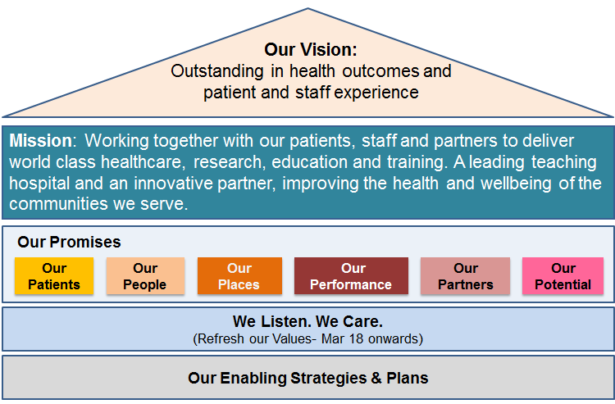

- Patients - We will ensure our patients receive consistently high quality, safe care with outstanding outcomes and experience
- People - We will build on our position as an employer of choice; with an engaged, developed and empowered team that puts patient care at the heart of everything it does
- Places - We will invest in our estate, equipment and digital infrastructure to support the delivery of high quality patient care
- Performance - We will consistently achieve our performance standards and make the best use of resources to contribute to an affordable healthcare system
- Partners - We will support the improvement of the health of the communities we serve through strong system leadership and innovative partnerships to deliver integrated models of care
- Potential - We will deliver world-class research and education and transform health through innovation

Our values are: Caring and helpful; Safe and Vigilant for our patients and colleagues; Being Clinically Excellent and driving innovation to meet the needs of our patients; Using our Resources wisely whilst; Providing Quality products, services and experiences for staff and patients

JOB SUMMARY

To provide first line management supervision of the cleaning and food services team as part of the zonal structure for cleaning and food services.

The post holder will ensure that sufficient staff are on shift to deliver the agreed level of service to all areas within specified zones.

The post holder will also carry out audits, monitor standards, develop action plans and track progress as required.

The post holder will also be responsible for undertaking the appraisals of their teams and ensuring mandatory training is completed.

KEY JOB RESPONSIBILITIES

- Responsible for the first line management supervision of the cleaning and food services team within a specified zone.

- Responsible for the appropriate deployment of staff to ensure that agreed service requirements are met over a 7 day period.

- To promote flexibility, teamwork and good working practices within the cleaning and catering teams.

- To undertake appraisals for staff within zonal area of responsibility.

- To undertake cleaning audits point of service audits and surveys in line with Trust requirements and ensure any rectifications are undertaken in a timely manner.

- Liaise with clinical staff regarding the delivery of service provision in cleaning and catering.

- Work with the Facilities Management Team to ensure continuous improvements to service delivery.

- Where necessary undertake cleaning and catering tasks to support the teams on an ad hoc basis.

- Provide and receive routine information, to be able to inform staff and patients about cooking processes food choices and menus available.

- Resolve staffing issues; which may include changing the method of service delivery reorganise menus at short notice; decide on alternative food options.

- Co-ordinate the requirements for the Trusts mini deep clean programme & add hoc Hydro peroxide requests.

- Ensure the availability of cleaning and catering consumables at all times and monitor usage.

- To stand in for colleagues in their absence in areas relating to the day to day running of specified areas of responsibility, plan staff cleaning / catering work; adjust staff rotas for unplanned absences; rotate visits for quality assurance spot checks.

- Ensure that the issue and control of keys / swipe card access is managed in accordance with departmental Procedures / Trust Policy.

- To assist the Training Team in the development and training of new and existing staff linked to personal.

- To assist staff with new procedures; Explain technical issues, such as COSSH regulations, or those providing training.

- Assist in the recruitment and selection process associated with the appointment of new employees.

- Organise interviews, staff rotas, equipment repairs.

- Implement relevant policies in Cleaning and Catering.

- Undertake first line management reviews on sickness absence, timekeeping and performance where appropriate and in line with Trust policies and procedures. Undertake investigations when required together with counselling of staff when dealing with staff issues.

- Ensure appropriate Health and Safety requirements are met and in particular COSHH and food safety. .

- Ensure infection control standards are met and adhered to.

- Ensure national cleaning standards are adhered to & Liaise closely with the infection control team to uphold trust standards.

GENERAL DUTIES

In addition to the key job responsibilities detailed in this job description all employees at Nottingham University Hospitals NHS Trust are expected to comply with the general duties detailed below:
Infection Control

To maintain a clean, safe environment, ensuring adherence to the Trust’s standards of cleanliness, hygiene and infection control.

The post holder is accountable for minimising the risks of infections and for the implementation of the Code of Practice for the Prevention and Control of Healthcare Associated Infections as outlined in the Health Act 2006. This includes receiving assurance of risk and embedding evidence based practice into daily routines of all staff.
Safeguarding children, young people and vulnerable adults

Nottingham University Hospitals is committed to safeguarding and promoting the welfare of children, young people and vulnerable adults. All staff and volunteers are therefore expected to behave in such a way that supports this commitment.
Information Governance
All staff have an individual responsibility for creating accurate records of their work and for making entries into and managing all NHS records effectively in line with the Health Record Keeping Policy and other Health Records and Corporate Records Management policies and procedures in order to meet the Trust’s legal, regulatory and accountability requirements.

Health and Safety

To take reasonable care to prevent injury to themselves or others who may be affected by their acts or omissions.

To co-operate fully in discharging the Trust policies and procedures with regard to health and safety matters.

To immediately report to their manager any shortcomings in health and safety procedures and practice.

To report any accidents or dangerous incidents to their immediate manager and safety representative as early as possible and submit a completed accident/incident form.

To use protective clothing and equipment where provided.

Whilst the aim of the Trust is to promote a co-operative and constructive view of health and safety concerns in the organisation, all staff must be aware that a wilful or irresponsible disregard for safety matters may give rise to disciplinary proceedings.

Governance

To actively participate in governance activities to ensure that the highest standards of care and business conduct are achieved.

General Policies Procedures and Practices

To comply with all Trust policies, procedures and practices and to be responsible for keeping up to date with any changes to these.

Working Conditions

This post will require a high degree of physical effort and will be exposed to tasks that may be described as unpleasant at times e.g. cleaning on sanitary areas, however all appropriate personal protective equipment will be provided to limit the risk to staff.
The post holder duties may require attendance on site outside of normal working hours to deal with staffing related matters, service issue or incidents.
The post holder may be requiring to work as part of a management on call rota.
The job may necessitate other duties to be carried out, as may reasonably be required the Head of Facilities - Cleaning/Administration Services within the Trust, subject to appropriate negotiations

.Job Revision

This job description should be regarded as a guide to the duties required and is not definitive or restrictive in any way. The duties of the post may be varied from time to time in response to changing circumstances. This job description does not form part of the contract of employment.

Service Review

A strategic review of all Trust services is taking place, as a result of which some services, or parts of some services, may transfer from one campus to the other. This will be decided in accordance with the most appropriate way to provide the best healthcare for patients in the future and all staff will be fully consulted on about the impact of any such decisions.
Job description reviewed date: June 2019

